**TnP Question Bank for the forthcoming batches** (upload at – bit.ly/QuesBank18)

You are requested to mention the following details in the best possible manner for the junior batches to have an upper hand during their placements. Pls feel free to add any other sections that you deem fit.

**Name –** Ankita Purkayastha **Enrolment No.** - 9915102140 **Batch** – E7

**Contact No. -** 8800784963 **Company’s Name and Profile** – Adobe,

Development Engineer

**Online Round:** Aptitude, 2 programming questions.

**Technical Questions** (Mention below all the technical questions asked during the interview and coding/technical round):

There were 2 technical rounds and 1 managerial round. All the three were elimination rounds.

Round 1:

1. Tell me about yourself.
2. Given a file , there’s a code written in it. You need to find out if the code is balanced (Balanced means there was equal number of opening as well as closing brackets ) in less time and no extra space.
3. Given a binary tree. Consider x-y axis. The root node is in the y axis. And a ray of light is coming from the north west direction. How many shadows can be seen in the x axis.(Hint: Bootom view of a binary tree).

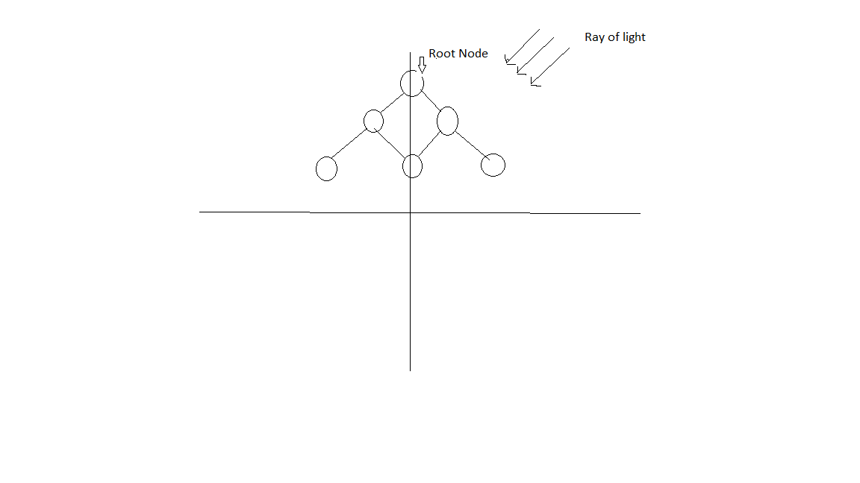

1. Some questions from OS.
2. What is ISR?
3. Explain your projects.

Qualified the round.

Round 2:

1. Tell me about yourself
2. Explain your projects.
3. Delete a node in singly linked list.
4. Given a number, find the next highest number using the same digits.(for eg if given number is 3498 next highest number is 3894
5. Asked few puzzles.
6. Questions from OS. Paging, external fragmentation, Internal fragmentation, difference between process and thread.

Qualified the round.

Round 3: Managerial Round

1. Tell me about yourself.
2. Why you want to change your field?
3. What is the thing you want to work on?
4. Why do you like programming?
5. Given a box there are 19 red socks 21 black socks. You take out one sock at a time. What is the minimum trials you need to have a pair of socks of same colour.
6. What is a process?
7. What is a thread
8. Can we start a process from a thread?
9. Given an array and a sum. Find out the pairs which give that sum. Explain the ways you can do it. You cannot use extra space and any sort function.

Qualified the round.

Round 4: HR round

1. Tell me about your strengths?
2. Why do you want to join Adobe?
3. What if you don’t get selected today?
4. How will you cope up with the top coders from IIT?
5. What if you have a manager who don’t appreciate?
6. Why do you have such a low CGPA?
7. What is the thing you regret in the last 4 years?

Result: Rejected.

My CG was 7.7 then. Maybe this was the reason for my elimination from the HR round. Whatsoever be the reason, I had a great experience and I learned a lot from this interview. Hope it helps you guys too to prepare for the interviews. Good luck!